Tinkerkit is kind of interesting, it’s idea was to make things even easier, which in a way it kind of did for some things, for others there is little to no point in tinkerkit.

For the most part Tinkerkit is a set of modules with a “universal” connector on them, they are color coded as to where to plug them in. (I)nput (O)utput analog.

Since Tinkerkit is a defunct hardware some information is getting hard to find.

So I am trying to find sites that talk a little about the connectors and some of the hardware, so that it can still be useful. Most of the modules use just three wires, 5v, signal, Ground and can be used with any Arduino.

There is a TWI connector, that as it turns out is just another name for the I2C on the Arduino, it’s 4 wire and works with other 4 wire modules (I2C) knowing the pinout of the connector you can figure out the pinout for the modules.

There is also a 4 wire Serial connector, same is true if you know the pinout you can figure out how to hook up the connect. Interesting enough dupont cables hook right up to the connectors.

Here is what I’ve found so far:

Thanks to the Internet Archive we get a final snapshot of tinkerkit website. Sad thing is while there are some tutorials, and a getting started guide. I didn’t see much if any infromation about the connectors.

<https://web.archive.org/web/20140726223700/http://www.tinkerkit.com/>

There is a guide on how to make your own modules, which can be handy. Even thou it goes into just what color to use and why you want to use that color...

<https://web.archive.org/web/20140723182054/http://www.tinkerkit.com/custom-modules/>

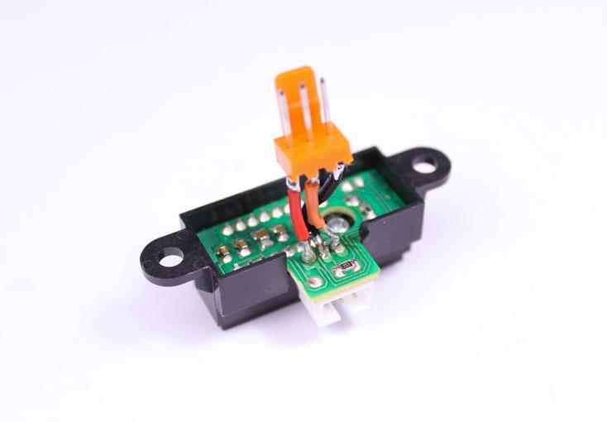

So the 3 pin connector is pretty simple, And depending on it’s color depends on if it’s connected to the Analog I/O or the Digital I/O

From Mike Barela Blog posting about the Esplora we get these nice pictures of the connectors.

<http://21stdigitalhome.blogspot.com/2013/01/arduino-esplora-tinkerkit-outputs.html>

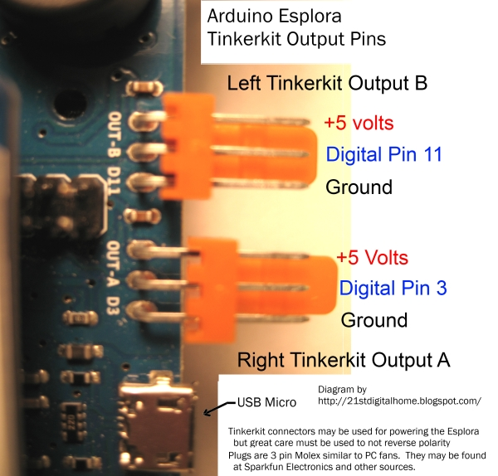

In the same block posting he connects a Xbee wireless module to the esplora using the digital pins for software serial. He also states these pins are PWM pins. It’s a good picture for the esplora board. We kind of need something a little more general thou.

From a Danduino Blog posting about the Tinkerkit LCD board/microcontroller we get an idea of how the TWI and Serial Pins work.

<http://danduino.blogspot.com/2015/03/the-tinkerkit-lcd.html>

These pictures are taken from that blog posting:

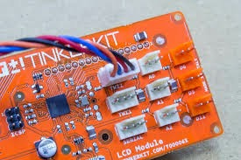

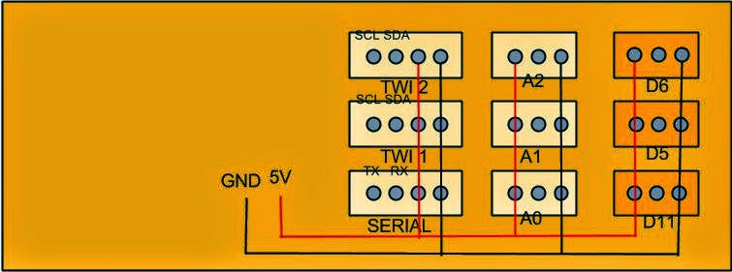

(I think this picture has the Analog and Digital pins wired backward, but the TWI and Serial appear right - This is based off looking at the color of the wire in the picture, and my own board. And from the picture of the esplora connector)

Taken from CR Blog we have one of the pictures only bigger.

<http://www.carobot.ca/blog/uncategorized/tinkerkit-tutorial-lcd-06-twi/>

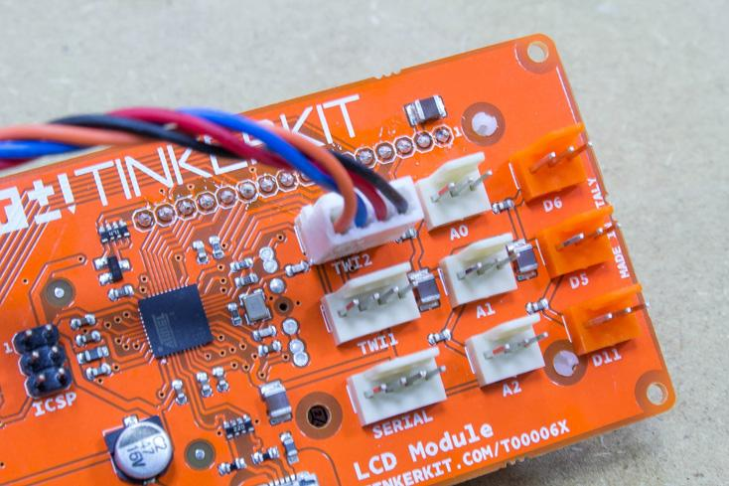

In this blog posting CR explains how to use the TWI ports and just what they are.

The libraries for all the modules and example code can still be found on Github,

it seems that someone is still working on (at least the software) this project. As one of the projects was recently updated (4 days ago as of Jan 10, 2016)

<https://github.com/TinkerKit>

Arduino.org is still making shields and boards that have the tinkerkit connectors on them.

Arduino.cc seems to put all the boards and shields that have these connectors in the “retired” area.

Tinkerkit seems like it just never took off at least here in the U.S. - It may be used in other parts of the world thou, it seems like it is well thought out, but wasn’t marketed well.